The Central Processing Unit (CPU), often referred to as the "brain" of the computer, is a critical hardware component responsible for executing instructions from programs and performing calculations. It processes data and coordinates tasks between all other hardware components.
________________________________________
Components of a CPU
1. Control Unit (CU):
o Directs the operation of the computer.
o Fetches instructions from memory, decodes them, and directs the execution.
o Coordinates data flow between the CPU, memory, and peripherals.
2. Arithmetic Logic Unit (ALU):
o Performs arithmetic operations (e.g., addition, subtraction) and logical operations (e.g., AND, OR).
o Handles calculations required by programs.
3. Registers:
o Small, fast storage locations within the CPU.
o Temporarily store data, instructions, and addresses during processing.
4. Cache Memory:
o High-speed memory located within or very close to the CPU.
o Stores frequently accessed data and instructions to improve processing speed.
5. Clock:
o The CPU clock synchronizes operations and determines the processing speed.
o Measured in GHz (gigahertz), indicating the number of cycles per second.
________________________________________
Key CPU Features
1. Clock Speed:
o Determines how fast the CPU executes instructions.
o Higher clock speeds typically mean faster performance.
2. Cores:
o CPUs may have multiple cores (dual-core, quad-core, etc.), allowing parallel execution of tasks.
o Multi-core processors are more efficient for multitasking.
3. Threads:
o Represents the number of tasks a CPU can handle simultaneously.
o Hyper-threading enables a single core to manage multiple threads.
4. Instruction Set:
o A collection of commands the CPU can execute (e.g., x86, ARM).
o Determines compatibility with software.
5. Architecture:
o Refers to the design of the CPU, such as 32-bit or 64-bit.
o Influences processing power and memory capacity.
________________________________________

How the CPU Works
1. Fetch: Retrieves instructions from memory.
2. Decode: Interprets the instruction to understand the operation.
3. Execute: Performs the operation using the ALU or other components.
4. Store: Saves the result back to memory or a register.
________________________________________
Types of CPUs
1. Desktop CPUs: Optimized for general computing tasks (e.g., Intel Core, AMD Ryzen).
2. Server CPUs: Designed for heavy workloads and multitasking (e.g., Intel Xeon, AMD EPYC).
3. Mobile CPUs: Focused on energy efficiency and compact size (e.g., ARM-based processors in smartphones).
4. Embedded CPUs: Integrated into devices like appliances or vehicles for specific tasks.
________________________________________
The CPU is central to a computer's performance, and advancements in CPU technology have significantly contributed to the growth of computing power and efficiency.
Bus architecture is a communication system within a computer that transfers data between components such as the CPU, memory, and peripherals. It acts as a highway for data flow, ensuring components can interact and work together efficiently.

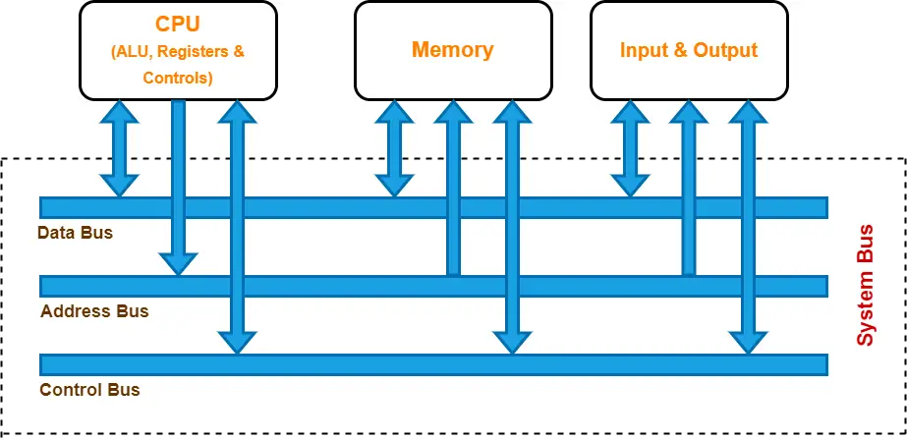

Key Components of Bus Architecture
- Data Bus:
  - Transfers actual data between the CPU, memory, and I/O devices.
  - Width (measured in bits, e.g., 32-bit or 64-bit) determines how much data can be transmitted simultaneously.
- Address Bus:
  - Carries memory addresses from the CPU to other components to specify where data should be read from or written to.
  - Width determines the addressable memory range. For example:
    - 32-bit address bus can address 2³² (4 GB) of memory.
    - 64-bit address bus can address much larger memory.
- Control Bus:
  - Sends control signals to manage and coordinate operations.
  - Examples of control signals:
    - Read/Write (R/W) signals.
    - Interrupt signals.
    - Clock signals for synchronization.

Types of Bus Architectures
- System Bus:
  - Connects the CPU, memory, and other major components.
  - Includes the data bus, address bus, and control bus.
- I/O Bus:
  - Connects peripheral devices like printers, keyboards, and storage to the system.
- Backplane Bus:
  - Common in industrial systems; allows multiple devices to connect via a shared physical bus structure.
- Internal and External Buses:
  - Internal Bus: Operates within the CPU to connect components like the ALU, registers, and cache.
  - External Bus: Interfaces the CPU with external devices (e.g., PCI, USB, and SATA).

Bus Topologies
- Single Bus:
  - All components share a single communication line.
  - Simple design but may face bottlenecks under heavy data traffic.
- Multiple Bus:
  - Uses separate buses for different tasks (e.g., a dedicated I/O bus and a memory bus).
  - Reduces traffic congestion and improves performance.

Types of Modern Buses
- Parallel Bus:
  - Transfers multiple bits simultaneously using multiple lines.
  - Example: PCI (Peripheral Component Interconnect).
- Serial Bus:
  - Transfers data one bit at a time using fewer lines, reducing electromagnetic interference.
  - Examples: USB, SATA, PCIe.
Advantages of Bus Architecture
- Cost-effective and simple to implement.
- Easy to add or remove devices.
- Standardized interfaces allow compatibility with various components.
Challenges
- Bottlenecks: Shared buses can slow performance when multiple devices request access simultaneously.
- Latency: Communication delays may occur, especially in complex systems.
Modern computer systems use advanced bus architectures, like PCIe and USB, to handle the growing demand for speed, efficiency, and compatibility.

